The pages and lines of the manuscript should be numbered consecutively (in Word: Layout section - Line Numbers - Continuous)

The text highlighted in blue is for explanatory purposes only and should be removed before submitting the manuscript.

REVIEW ARTICLE
SCIENTIFIC SPECIALTY

MANUSCRIPT TITLE

HIGHLIGHTS
2-3 sentences that reveal the main results of the research

ABSTRACT
Provide a short abstract, avoiding abbreviations and reference citations. .An unstructured abstract (without division into structural elements for a descriptive review) or a structured abstract (for a systematic review and meta-analysis) of 250–300 words.
The type of review (descriptive, systematic review or meta-analysis), literature search methodology, databases, and search period must be indicated.
It must indicate what is new in the scientific article in comparison with others related in subject matter and purpose. The abstract should not include references to literature or use abbreviations, except for commonly used abbreviations and symbols. Abbreviations must be expanded upon the first mention.
Aim. …
Methods. …
Results. …
Conclusion. …

Keywords: …5-8 words

Ethics statements. Please, include a statement that informed consent was obtained from patients or their parents or guardians and that human experimentation guidelines in accordance with the ethical standards of the Helsinki Declaration were followed in the conduct of clinical research or that animal experimentation guidelines were followed in animal studies.

Abbreviations

Non-standard abbreviations should be defined at the first occurrence and introduced only where multiple (3 times or more) use is made. Authors should not use abbreviations in headings.
Abbreviations do not need to be defined, even at first mention, if they are the standard abbreviations Only generally accepted abbreviations should be used (do not introduce your own), the decoding of which must be given in the text once: before the first mention of the abbreviation. All abbreviations used in the manuscript must be decoded, except for symbols of chemical elements and abbreviated names of well-known metric units.
It is worth considering that the abundance of abbreviations in the text makes it difficult to read, since the target audience is not limited to narrow specialists, but includes a wide medical audience.
CD - cluster of differentiation
IL - Interleukin

INTRODUCTION
It highlights the current state of the issue under consideration with relevant references for the last 3-5 years to the most significant publications to justify the need for the study, its scientific novelty and practical significance.

AIM
The study aims to assess….

MATERIALS AND METHODS

The type of review (descriptive, systematic review or meta-analysis), literature search methodology, databases, search period, keywords used for the search must be specified; inclusion and exclusion criteria must be specified for a systematic review and meta-analysis. For meta-analysis, the statistical processing program, visualization tool (publication selection flowchart), and methods for assessing the heterogeneity of the obtained data must be additionally specified. A graphical representation of the publication selection flowchart is provided.

RESULTS

The results are presented in a logical sequence in the text, tables and figures. A descriptive review can be presented as a text with references to sources of information, and the text can be divided into sections.
For meta-analysis, a block diagram of the selection of publications is provided. The text should clearly indicate the reference to tables and illustrations. (Figure 1)

Figure 1. Flow chart for study selection
The data of the publications included in the meta-analysis are presented (Table 1)
Table 1. Characteristics of included studies.
Study | Research power | Experience  n/N | Control  n/N | Average age (years) | Odds ratio OR | 95% [CI]
Boulle et al. 2021 | 22308 | 343/26 | 21965/599 | 63,0 | 2,78 | 1,90 – 4,06
Chen Т et al 2020 | 203 | 4/0 | 199/26 | 54,0 | 0,73 | 0,04 – 13,22
Total (95% confidence interval) | 47145 | 618/65 | 46527/2529 | 54,9 | 2,24 | 1,46 – 3,43
Heterogeneity: Tau² = 0.14; Chi² = 14.14, df = 9 (P = 0.12); I² = 36%
Test for overall effect: Z = 3.72 (P = 0.0002)

The results of the meta-analysis are presented (Figure 2)

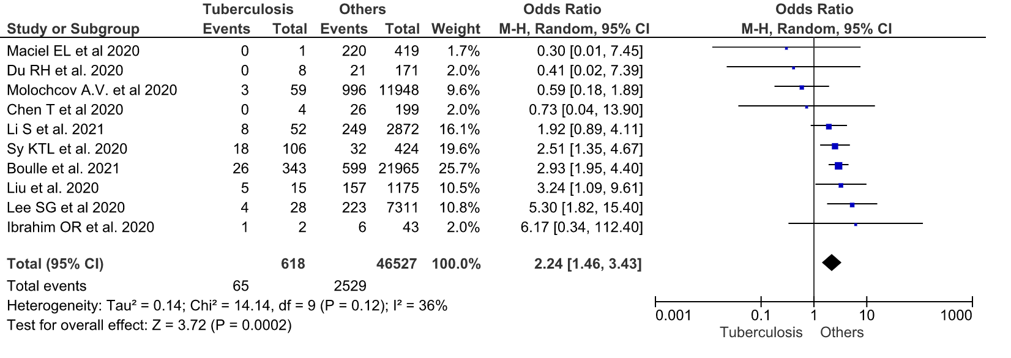

DISCUSSION

It is necessary to highlight new and most significant aspects of the results of your research and compare them with data from other studies, if any. Data not reflected in the results cannot appear in the discussion.

CONCLUSION

Should include clear and concise summaries of the experiment, without generalities, and rea-sonable recommendations.
The conclusion should not exceed one paragraph (5-7 brief conclusions of your work).

REFERENCES

Not more than 60 sources.
The list of references includes only published materials (links to Internet resources are allowed). Self-citation should be avoided, except in cases where it seems necessary (for example, if there are no other sources of information, or the present work was carried out on the basis of or in continuation of the cited studies). Self-citation should be limited to 3 references.
It is recommended to include relevant works published over the past 3–5 years in the bibliography.
These may be scientific articles and other peer-reviewed materials that contain DOI links (a unique digital identifier of the article in the Cross Ref system), PMID (an identification number assigned to each publication in the PubMed database), for publications in Russian - EDN (eLIBRARY Document Number - an identifier in the RINTS database).
Orders, regulations, State standards, laws, methodological recommendations, electronic resources are drawn up as footnotes. It is not recommended to include dissertations, textbooks, conference materials, unpublished works, preprints, textbooks, textbooks, dictionaries, newspapers, popular science journals, materials contained in Wikipedia, StatPearls [Internet].
Russian-language sources are given first in Russian and then in English. All data are given as in the original source (see the journal's website). At the end of the bibliographic description, an indication of the original language of the publication is placed (In Russ.).
Example:
- Jiang Y., Xie Y., Fang P., Shang Z., Chen L., Zhou J., Yang C., Zhu W., Hao X., Ding J., Yin P., Wang Z., Cao M., Zhang Y., Tan Q., Cheng D., Kong S., Lu X., Liu X., Sessler D.I. CT-LIFE Study Collaborators. Cognitive training for reduction of delirium in patients undergoing cardiac surgery: a randomized clinical trial. JAMA Netw. Open. 2024;7(4):e247361. https://doi.org/10.1001/jamanetworkopen.2024.7361. PMID: 38652478; PMCID: PMC11040409.
- Relander K., Hietanen M., Rämö J., Vento A., Tikkala I., Roine R.O., Lindsberg P.J., Soinne L. Differential cognitive functioning and benefit from surgery in patients undergoing coronary artery bypass grafting and carotid endarterectomy. Front. Neurol. 2022;13:824486. https://doi.org/10.3389/fneur.2022.824486. PMID: 35350398; PMCID: PMC8957972.
- Sanz-Horta R., Matesanz A., Gallardo A., Reinecke H., Jorcano J.L., Acedo P., Velasco D., Elvira C. Technological advances in fibrin for tissue engineering. J Tissue Eng. 2023;14:20417314231190288. https://doi.org/10.1177/20417314231190288. PMID: 37588339; PMCID: PMC10426312.
- Matveeva VG, Rezvova MA, Glushkova TV, Sergeeva AV, Krivkina EO, Antonova LV, Barbarash LS. Structure and properties of a hydrogel with an interpenetrating polymer network fibrin/polyvinyl alcohol as a modifying coating for small-caliber vessel prostheses. Circulatory pathology and cardiac surgery. 2023;27(2):74-86. (In Russ.). https://doi.org/10.21688/1681-3472-2023-2-74-86. EDN: GEDUUC

